
Report
into
Subject Classifications
in PANDORA

Colin Sweett
(April 2009)
Produced as part of the NLA Graduate Programme

Table of Contents
Table of Contents 2
1. Executive Summary 3
2. Background and purpose 3
3. Scope and methodology 3
4. Recommendations 3
5. Summary of findings 4
5.1 Updating ceased titles 4
5.2. Updating ongoing titles 4
5.3. Maintaining a record of updated titles 4
5.4. Selecting subject categories for new titles 5
5.5. Titles no longer online 5
6. Conclusion 5
7. Appendices 5
7.1. Lists of titles 5
7.2. Workflow Diagrams 6

Executive Summary
The purpose of this report is to outline the process for updating both ceased and continuing titles within the PANDORA Archive. The titles requiring updating are those created before March 2008, when new subject listings were implemented. In developing this report both current staff workflows and the significant role of PANDORA partner agencies were considered. The report provides a number of recommendations focused on the most efficient method to update titles. In addition both detailed workflow diagrams and attached spreadsheets are included to clearly outline and facilitate the process required to update titles. As titles are updated it is hoped that some of the earliest titles in PANDORA will become more accessible to users.

Background and purpose
The PANDORA public interface provides access to archived resources through browsable subject listings. For the greater part of the time we have been archiving web materials these subject listings were quite broad and became increasingly of little value to users. Adding new subject headings was complicated in the past as changes had to be made by IT staff. The latest version of PANDAS allows for the creation and editing of subject listings by web curators. In March 2008 a new set of subject listings was implemented. However, existing archived titles need to be re-aligned with the new headings in order to achieve value for users from these headings.

Scope and methodology
This report considers the best method to update the subject headings of ceased and ongoing titles within the PANDORA Archive. In developing its recommendations and workflows the report has taken into account the current workflows of web archiving staff, the significant involvement of partner organisations in the web archiving process, and the functionality available within the PANDAS Management System. It is the aim of this report to provide clear and detailed instructions to enable staff to successfully update subject headings in existing titles.

Recommendations
Detailed information on the recommendations is included in Section 5 Summary of findings. These recommendations have been developed through considering the most efficient workflow solutions for updating titles in PANDORA and through observations on current workflows and consultation with staff in the Web Archiving Section.

Recommendation 1 – That web archiving staff follow the procedures outlined to update ceased titles in the PANDORA Web Archive, by editing or adding additional subject categories.

Recommendation 2 – That web archiving staff update subject categories for ongoing titles during the processing of scheduled gathers.

Recommendation 3 – That web archiving staff ensure a spreadsheet is maintained with updated titles recorded.

Recommendation 4 – That web archiving staff ensure that meaningful subject categories are selected for new titles.

Recommendation 5 – That web archiving staff update the status of all titles that are listed as no longer online.

Summary of findings
The PANDORA archive contains over 28 000 titles many of these titles were created before March 2008 and thus are indexed under old subject listings. It is necessary to update the subject listings in these titles to improve the user experience. In undertaking this task effectively it is necessary to involve not only the National Library of Australia but the PANDORA partner agencies as they provide significant input into the archive. This section describes the process undertaken to update titles in PANDORA and should be read together with the accompanying workflow illustrations in Appendix 7.2.

5.1 Updating ceased titles

There are over 10,000 ceased titles in the PANDORA system that were created before March 2008 and thus require updating. Ceased titles refer to those that are no longer being gathered and thus are not regularly updated. The process outlined in the workflow diagrams in Appendix 7.2 focuses on the most efficient method to undertake this. To further the implementation of this process spreadsheets have been created for each agency listing all relevant ceased titles requiring updates. These can be adapted by PANDORA partner organisations to use in their work allocations This process contributes to achieving recommendation 1, that web archiving staff follow the procedures outlined to update ceased titles in the PANDORA Web Archive, by editing or adding additional subject categories. It is estimated that each title will take between one and two minutes to complete once the staff member becomes familiar with the process. It is envisaged that this work will be completed progressively over time.

5.2. Updating ongoing titles

Outdated subject headings also exist within PANDORA for ongoing titles. It is important to ensure that these titles are updated to ensure consistency across PANDORA. However unlike ceased titles these items are regularly updated by web archiving staff. As such there is the potential to unnecessarily duplicate work if staff time is specifically allocated to update these titles.

The most optimal method for updating continuing titles is detailed in recommendation 2 that web archiving staff update subject categories for ongoing titles during the processing of scheduled gathers.. Staff should ensure ongoing titles have up to date subject listings which include low level categories when processing a gather. Agency specific spreadsheets have also been created listing ongoing titles that may need updating. When processing a gather it is recommended that staff update the title and check it off on the spreadsheet to avoid repetition. This is particularly important as some titles are gathered monthly while others only bi-annually. By undertaking this process we can ensure that all titles in PANDORA remain up to date.

5.3. Maintaining a record of updated titles

As discussed in 5.1. and 5.2. maintaining lists of updated titles is essential to ensure efficient work practices and to avoid duplication. In Appendix 7.1. example lists are given for each agency listing ceased and ongoing titles requiring updated subject listings. Once the staff member has updated the title they should ensure it is recorded on the spreadsheet. This will ensure that recommendation 3 that web archiving staff ensure a spreadsheet is maintained with updated titles recorded is fulfilled.

It is suggested that PANDAS administrators coordinate the master spreadsheet which lists all titles requiring updates. They then compile lists for each staff member (with reference to the ownership of titles) ensuring an equal distribution of titles. Once the staff member has updated the titles they send the completed list to the supervisor who then incorporates the data into the master spreadsheet.

5.4. Selecting subject categories for new titles

During the investigation stage of this project it was noted that a number of titles within PANDORA have not been allocated useful subject headings. For example the number of titles within the top level categories runs into the thousands. While PANDORA offers a number of search methods, browsing subject categories is frequently used. Thus it is vital that we provide effective subject listings as a finding aid. In making the recommendation that web archiving staff ensure that meaningful subject categories are selected for new titles it is envisaged that staff will assign at least one lower level subject category to a title. If a title is of a general nature or covers a multiplicity of areas multiple subjects should be assigned. While allocating titles to top level subject areas is fine it is not a useful finding aid if this is the only category for the title.

5.5. Titles no longer online

During the implementation stage of this project a number of titles were found listed as ongoing and also marked as no longer online. Once a title is no longer online its status should be changed to ceased. This ensures that correct information about the title is displayed to the public on the title entry page, thus the recommendation that web archiving staff update the status of all titles that are listed as no longer online. In addition to this once their status has been changed subject headings should also be updated. To avoid possible repetition it is suggested that this process be undertaken after the agency’s other ceased titles are updated.

Conclusion
Once these recommendations are completed the find-ability of titles in PANDORA will increase as these titles are updated to reflect more detailed subject categories. There is no set timeframe for the update process to be complete. As the task has been designed to be incorporated into current workflows it is not expected to adversely impact on staff workloads. It is envisaged that the update process will be completed in manageable sections so staff are not overwhelmed with work and return to it at a later time. It is hoped that through this update process some of the earliest titles in PANDORA will become more accessible to users.

Appendices

Lists of titles

These Excel spreadsheets contain information on titles that each partner agency needs to update in PANDORA. They list both ceased and ongoing titles under separate tabs. Each agency should receive a copy of their specific spreadsheet as an attachment to the report.

AIATSIS.xls
Film and Sound.xls
NLA.xls
NSW Library.xls
NT Library.xls
QLD Library.xls
SA Library.xls
VIC Library.xls
WA Library.xls
War Memorial.xls

Workflow Diagrams
The following process has been devised to assist web archiving staff locate and update subject categories in PANDORA. Note that spreadsheets (listed in Appendix 7.1) have been complied which list all titles requiring updating. If using the spreadsheet go to step five.

Step One – Log in to PANDAS and open the search menu. Under Title Name enter an * to include all records, then open ‘Limit Search to’
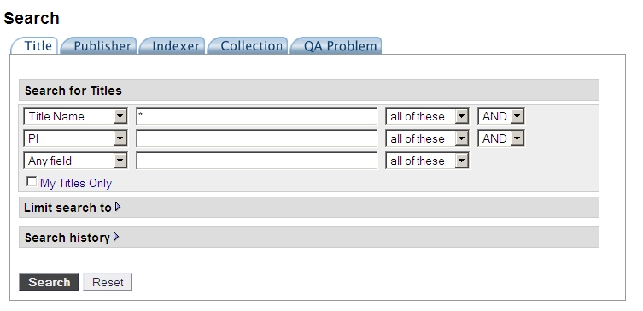

Step Two – With the Limit Search expanded fill in the following fields; Status = ceased (or permission granted for ongoing titles), Agency = your agency e.g. NLA, Registration Date = Between ___ and 28/02/2008 (this is the date that the expanded subject headings were implemented in PANDORA), Check the Archived Titles Only box (this will search titles that contain a gather). If searching for permission granted titles that are no longer online Check the No Longer Online Only box.
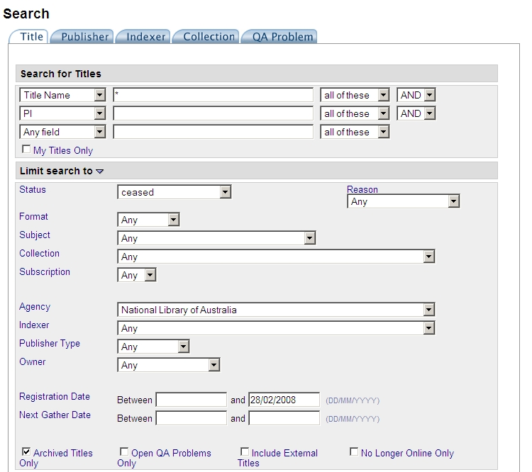

Step Three – A further limiter can be specified to indicate the ownership of the title. This can be useful to produce a list of titles for a specific staff member to update.
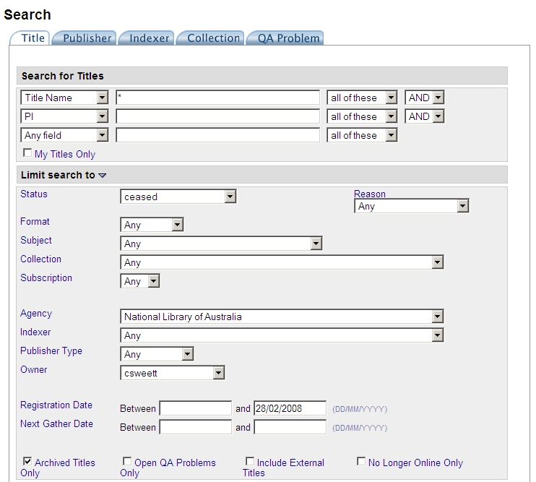

Step Four – Conduct the search (go to step six)
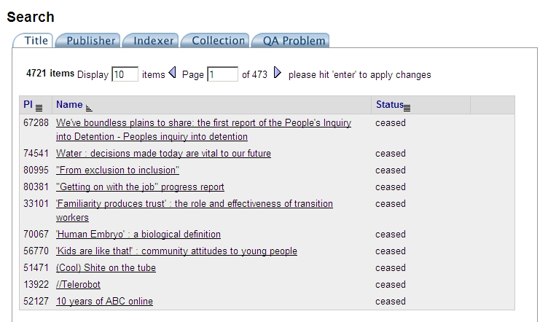

Step Five – This step shows how to open titles directly from the supplied spreadsheets (Appendix 7.1). Ignore this step if searching for titles through PANDAS. Copy the PI (Persistent Identifier) for the title and from the search page in PANDAS paste the PI and conduct the search.

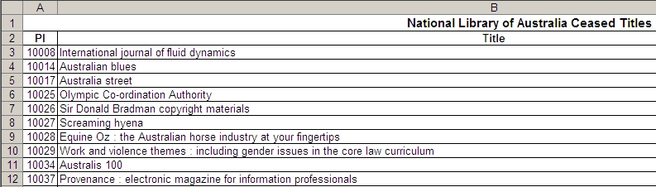

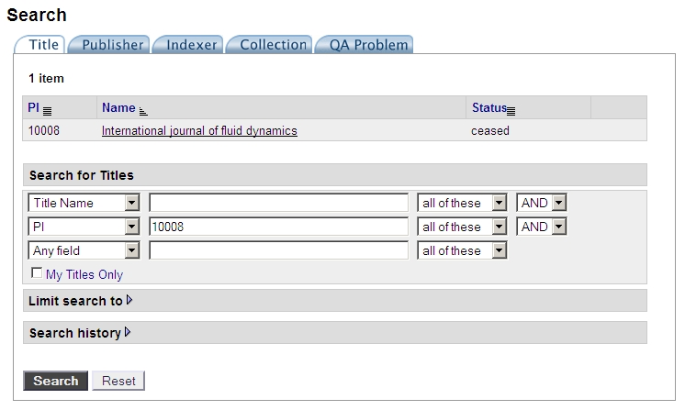

Step Six – Click on a title to check the subject category. In this example the title has a top level subject only. If the title has lower level subject headings e.g. Society & Social Issues > Social Problems and Action it may have previously been updated, check if off on the spreadsheet and move onto the next item. You need to be the owner of the title to edit it. If you are not the owner click Transfer (see step seven) or if you are the owner click Publish to view the archived instance (go to step eight).
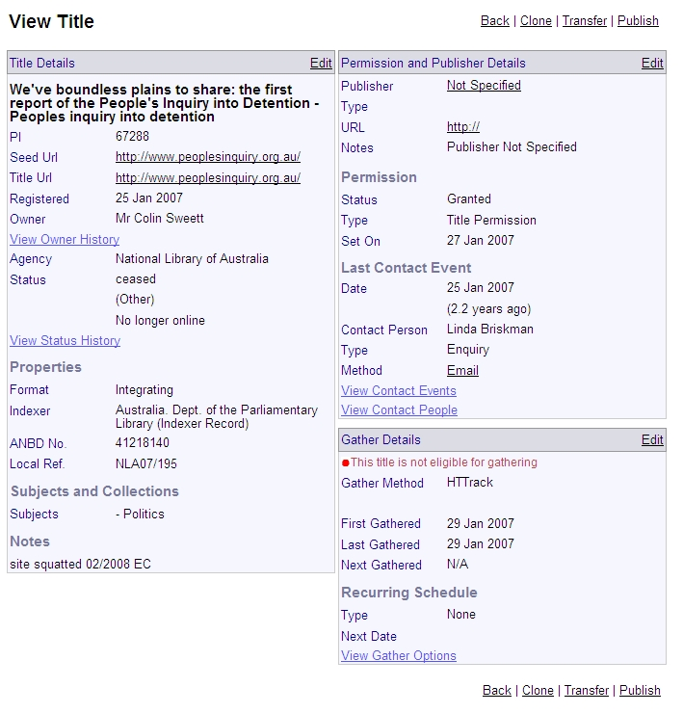

Step Seven – Select yourself as the new owner of the title the click Transfer to confirm. You will return to the View Title screen and can the select Publish.
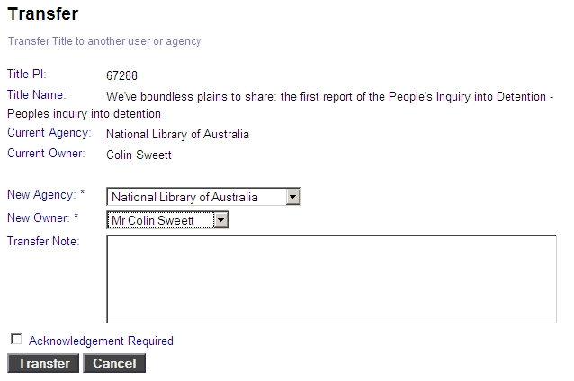

Step Eight – Open the archived instance by clicking the link shown. The page will open in a new window/tab. Check the content of the page to determine the most appropriate subject heading/s. Click Cancel to return to the View Title page.

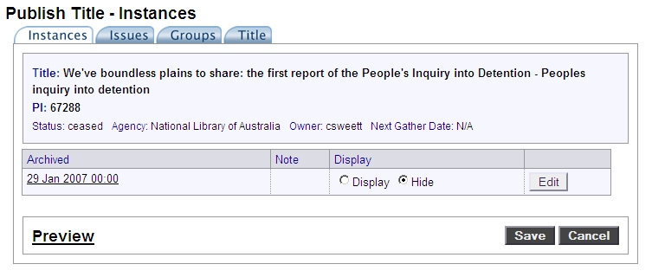

Step Nine – From the View Title page click on edit under the Title Details tab to edit the subject headings and select the appropriate subject/s from the drop down menu.

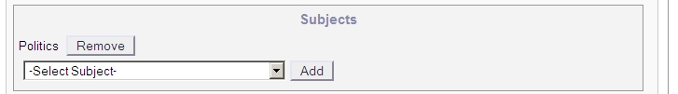

Step Ten – Once all the subjects have been added click Save.

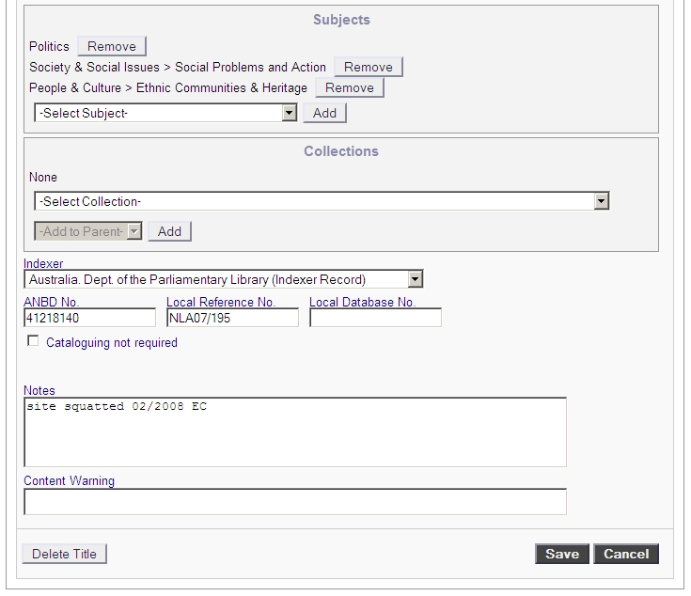

Step Eleven – You will be returned to the title details page. Click on Search to return to the saved search and repeat the process for the next record. Mark the item completed on the spreadsheet.
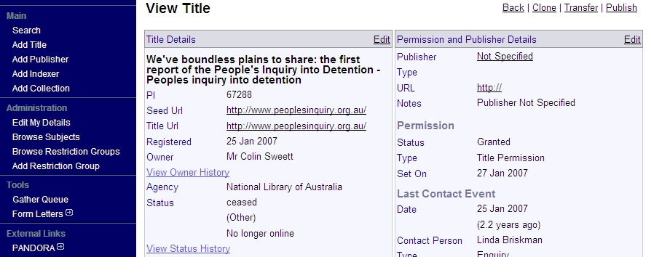

Common Error Messages and Fixes
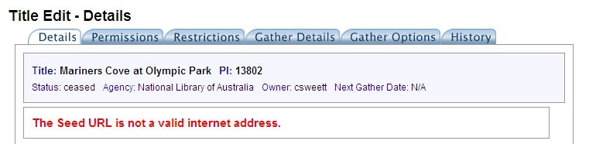

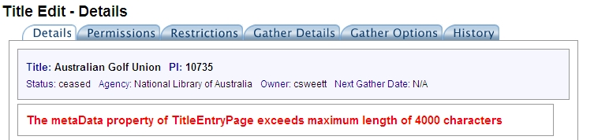
This indicates that the URL is invalid in some way. Check the seed and title URLs to check they are correct i.e. contain http://. Also check that there are no spaces at the end of the URL as that is a common cause of this error.

This problem will only be found on titles that are linked to large collections. The message indicates that the number of catalogue record metadata elements is too large for the system field. To resolve this, cancel out of the page you are in, you will lose any changes you have made but this can’t be helped. Go back into the Title, click on the Publish tab, then open up the Title tab, in the metadata field manually remove the metadata fields (taken from the cataloguing fields 600, 650, 700) that do not directly apply to the individual title. Save the record.

An example of a metadata entry that can be deleted:
<META NAME="DC.Creator" SCHEME="LCNA" CONTENT="corporateName=Telstra (Organisation)">

